**SNAKE GAME:**

**CODE:**

// C program to build the outline

// boundary using draw()

#include <stdio.h>

#include <stdlib.h>

int i, j, height = 30;

int width = 30, gameover, score;

// Function to draw a boundary

void draw()

{// system("cls");

for (i = 0; i < height; i++) {

for (j = 0; j < width; j++) {

if (i == 0 || i == width - 1 || j == 0

|| j == height - 1) {

printf("#"); }

else {

printf(" "); }}

printf("\n");}}

// Driver Code

int main()

{// Function Call

draw();

return 0;}

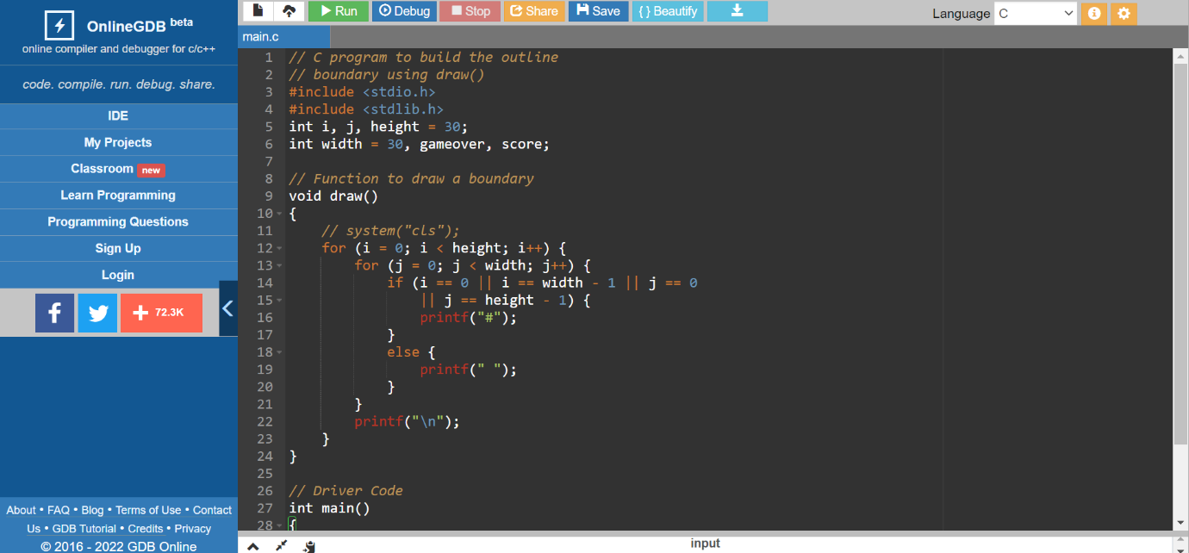

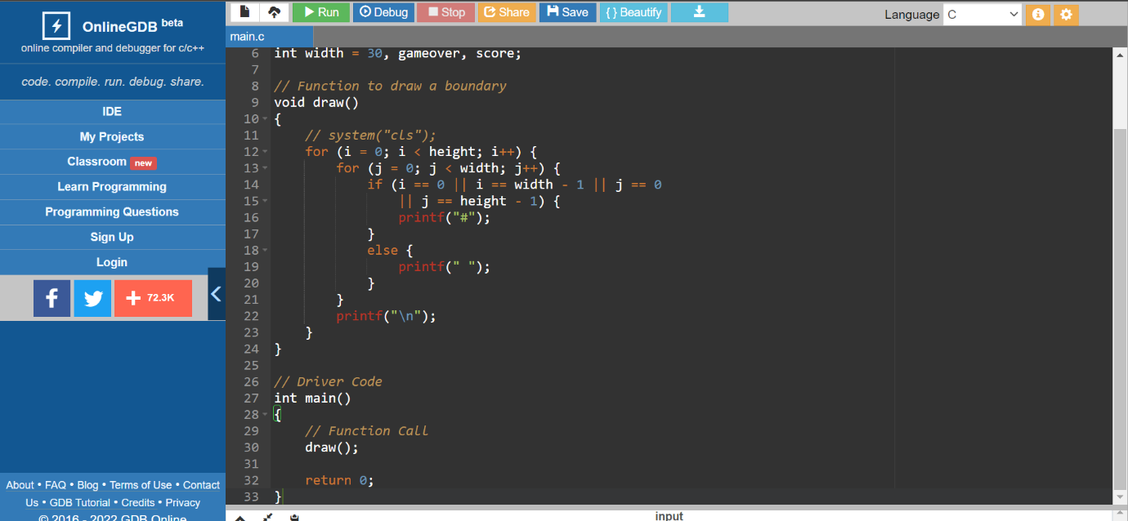

**OUTPUT:**

##############################

# #

# #

# #

# #

# #

# #

# #

# #

# #

# #

# #

# #

# #

# #

# #

# #

# #

# #

# #

# #

# #

# #

# #

# #

# #

# #

# #

# #

##############################

